POWER GENERATION – NEW ERA
Concept & Design – Patent Application No.4110/CHE/2014, dt.22-08-2014
In Hydro Electric Power Generation Projects, we are generating Power with the help of accumulated water in Reservoirs at height. We utilize the down flow water Pressure to rotate Turbines.
In this Project, we use people weight coming down from height, to rotate Turbines.

For example,
- On Tirumala Hills, there will be 50,000 people at all times for generations together and daily. 1, 00,000 people are coming down and going up Hills for Lord Balaji Darshan. We can use their movement in Power Generation using Roller Coaster Technology.

Power Generation on Tirumala Hills. Calculations theoretically with formulas.
From SRIVARI METTU to Tirumala Hills the Slant Distance (say) 2 K.M. = 2,000 meters.
Approximately, how much Power Can be generated when 10 Tons Load
(8 Tons Bus + 2 Tons for 50 Passengers in the Bus) slides down on trolley.

Tirumala Hills

2,000 meters distance

Srivari Mettu (steps way)
A layman’s -- ‘Power Generation Calculations’. – 550 M.W.
As per notes from attachment, (Work & Energy Chapter – PAGE 6) the following is the ‘Power Generation Calculation’.
Please follow Link:-
http://www.onlineconversion.com/energy.htm
One trip - 10 Tons Load (20 – Passenger filled car weight 2 Tons + 8 Tons Bus weight) generates 278 watt per hour as per enclosed attachments. -  formula:- (load in kgs x gravity x ½ distance)  10000 x 10 x 1000 = 10,00,00,000 Joules = 27777.8W | 27,778  Watts per hour
To transport up & down Hills, Pilgrims – 1,00,000 per day @ 50 persons in Bus per trip, the RTC will ply down 20,000 trips | 20,000  trips per day
For every Trip load the Power generated will be | 28 K W
For 20,000 trips down | 560 m w

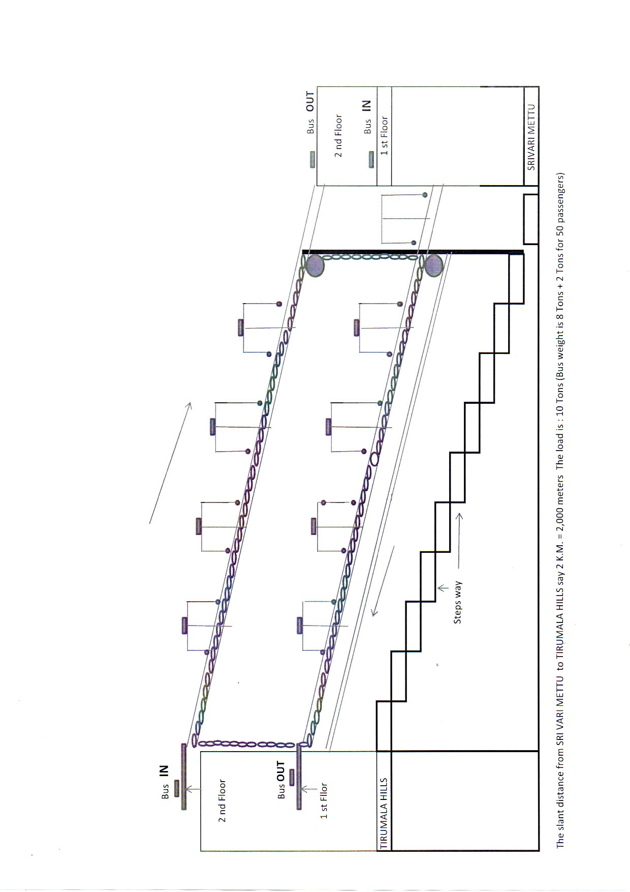

Roller Coaster image & Link:-
https://encrypted-tbn1.gstatic.com/images?q=tbn:ANd9GcS8yIRtLgXdodymqOlXCJu4eJvlEMH7bZba_3_oI4I5K3hLWfju
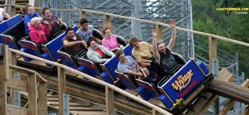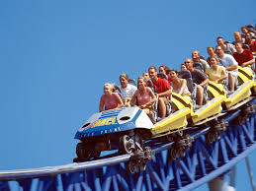
http://www.sciencechannel.com/video-topics/engineering-construction/machines-rollercoaster.htm
These images are showing Public coming down on Roller Coaster in open cars, whereas, in our Project, we can arrange cars enter in closed Chambers, which roll down. These cars filled with Pilgrims who are chanting ‘Govinda nama Sankeerthan’ during journey. In other words, we are providing ‘Garuda Seva’ to Pilgrims by transporting them up & down.
- At Chennai Central Railway Station, passengers getting down will move to Park Station to reach various parts of City through sub-urban Railway. A very little per cent age of Public depend on their own vehicles, 3- wheelers or Public Transport.
We can shift the people from Chennai Railway Station to Park Station using Roller coaster Technology and also we can generate Power using their weight.
We can arrange 20-seater Passenger trolleys in racks readily available on the platform. When Passengers getting down, they will be collected in trolleys and lifted to a height, say 30ft in the Chennai Central Railway Station Building and then Rolled down to Park Station.
With this Project, Power Can be generated and along with shifting of men / material between Stations.
--------------------------------------------------------------------------------------------------------------------------------------
- B R A W O
BENAGALURU RAIL & ROAD PATH WAY PROJECT
_______________________________________________________________________________

In the 24 hours of the day there may be 50 to 60 trains are ‘coming in’ and ‘going out’ of Benagaluru Railway Station. With every train bringing in 1000 passengers each, the number of passengers it is handling (1000 * 50) 50,000 people. And out of them (say) 5% will ‘go out / coming in’ in their own Vehicles, another 10% use Autos, the remaining passengers will come to Kempa Gowda Bus Station to go to their destinations through Buses.

Can we provide them easiest way to reach the Bus Station?

Project Name: - BENAGALURU RAIL & ROAD PATH WAY PROJECT.

-------------------------------------------------------------------------------------------------------------------------------------

People cross the Railway Platforms through “Foot Over Bridge”. The Foot over Bridge height say 30 ft height. If we use a Lift for another 30 ft height, totaling the height is 60 ft height. From that height at the Centre of the Railway Platforms to Bus station we provide, a Path Way. It is just like a RAMP. People come down easily to Bus Station without any hurdles, like crossing Platforms, parking area, subway, steps, etc.

We can provide trolleys with 20 passengers (2 Tons weight approximately) each which can slide easily to the distance and save the time & energy of the Passengers.
Advantages in this Project:-
- There is no Private Property in between these two points – Rly Stn & Bus Stn.
- The height of the Foot Over Bridge at Railway Station and the Ground Level at Bus Station may be more than 60 ft
- In addition movement of men / material, there will be scope of Power Generation –
By sliding the 2 Tons Load Trolleys on the Rails on RAMP along with Pathway.
----------------------------------------------------------------------------------------------------------------------------------

A layman’s -- ‘Power Generation Calculations’. - .5 M.W.
As per notes from attachment, (Work & Energy Chapter – PAGE 6) the following is the ‘Power Generation Calculation’.
Please follow Link:-
http://www.onlineconversion.com/energy.htm
-----------------------------------------------------------------------

These calculations I made for Benagaluru Path Way Project.
2Tons Load (20 – Passenger filled car) generates 278 watt per hour as per enclosed attachments.  2000 x 10 x 50 = 10,00,000 Joules = 278W | 278 W
When train arrives into Railway Station, let us say, 1000 Passengers reach, get down and use the Transport will be 800 nos. 800 Passengers will be transferred in 40 Loads (800/20 = 40). | 40 Loads
For every ‘four’ loads the Power generated will be more than 1 Kilo Watt  (4*278 = 1,112). | 1 K W
With the Passengers in one train (40 Loads) we can generate 10 Kilo Watt Power per hour. | 10 KW
With the Passengers from 50 trains per day, we can generate  50*10 = 500 (.5 MW) Power. | 500 KW =  .5 MW

Concept & Design – Patent Application No.4110/CHE/2014, dt.22-08-2014

30 ft.
100 Meters


 |  |  | "How much Power required to lift 2 tons Load to 30ft height"
 |  |  | "2000x10x9 "  Answered by aphoenixwithoutwings

2000 x 10 x 9 = 1, 80,000 Joules
Hence, Power requirement to lift 2 Tons Load (20-Passenger trolley) to a height of 30 ft is: - 50 watt per hour as per following conversion link:
http://www.onlineconversion.com/power.htm.


