Vital Mobiles And The Disease Tester
In 2016, nearly 2 million Americans were infected with gonorrhea, syphilis, and chlamydia. According to the Centers for Disease Control and Prevention, it is the highest number of these sexually transmitted diseases ever reported. According to an estimate by CDC, around 20 million new STD infections occur every year in the U.S. This is the reason why it's so vital to get tested frequently and be honest with your new partners (and Doctors) about your sexual activities. Mobile Vitals and Disease Tester is a product which comes in different types the All in one Unit allows you to choose vital testing and blood testing. The purpose of this device is to configure it for virus testing, diabetes, and vital tests. This wireless blood device has almost 50 known viruses stored and the most known virus signatures which scans the human for those diseases. This device offers a convenient and quick testing method for human diseases which results can be emailed to Doctors.

As if dating weren’t hard enough, singles in America have one more thing to worry about: the rise of STD’s. The excitement of being in another country and meeting new people might encourage you to do things you would not not normally do when at home, such as engaging in unprotected or casual sex with new partners. Regardless of what kind of sex you’re having, it’s a good idea to keep it protected. Protection is without a doubt the best form of preventing STDs and HIV/AIDS for sexually active people. Living with a sexually transmitted diseases disturbs not only your bodily health, it affects you emotionally, too. It can also take a toll on your romantic relationship. Whatever it is you feel that’s different, get tested with Mobile Vitals Devices. If you are sexually active, you should be getting tested at least once a year, regardless of whether you are monogamous.

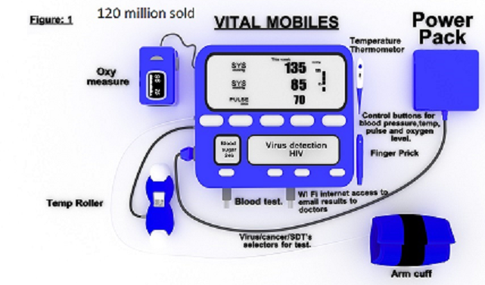

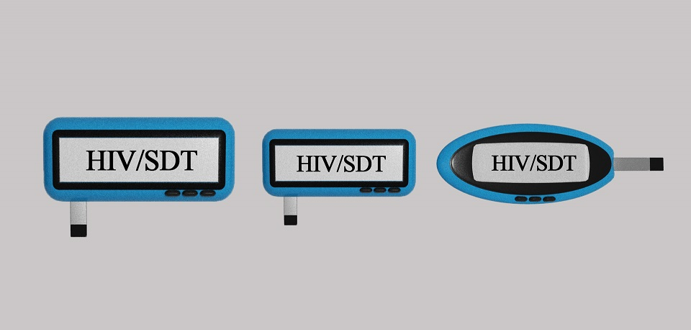

Vital Mobile and Disease Tester devices and its accessories will let consumers diagnose and monitor a wide range of conditions. These device uses one drop of blood with nanostrips and compares the virus signatures saved on NVRAM to the blood's contents. The use of innovative medical devices and wireless technologies to support the success of health objectives has the prospective to change the face of health service delivery across the world. Easy, regular, precise testing of the disease might make timely detection and diagnosis. Diagnosing conditions earlier can lead to more effective treatment. The purpose of this device is to offer a mobile solution which can test vitals and disease for people at home and with the Disease Mobile devices for on the go at bars, nightclubs, vacations, and parties.

Technology has become gradually significant over the recent years. And investments in technology have increased as a result. Vital mobiles and the disease testing devices present an opportunity for investors who share the same vision. It is part of a billion dollar industry and will increase to grow because of its demand and usability in human life. These technologies can essentially shift the way that health care is provided and consumed. It is a thrilling research and development area through which innovative technologies can improve and expand testing for STDs. Precise and real-time patient monitoring has appeared as a crucial trend in healthcare industry owed to which numerous medical device are incorporating wireless technology to keep a check on patients regularly. The use of wireless technology has increased patient’s mobility at the hospital or at home. Clinicians and tech experts we’ll be using small devices, similar to pregnancy testing kits which will tell people rapidly and secretly if they have caught an infection through sexual contact.

Conclusion
The doubt of not knowing if you are about to get a disease is now over . Vital Mobiles and the Disease Tester device has made diagnosing more mobile and reliable allowing you to know before hand if you or your partner are infected before proceeding with sexual activity. The best part about getting tested with vital mobile device for STDs is that once you get it over with, it can actually put your mind at ease. STD testing is a regular part of being responsible and taking care of yourself. So get Vital Mobiles and the Disease testers Today.

