Vital Mobiles and the Disease Tester
When it comes to an annual checkup at the doctor’s office, the first thing that comes to mind is breath tests, reflexes, and blood-pressure screenings. Until recently, doctors haven’t had much to go on beyond basic tests and normal updates from patients themselves to measure their overall health. However, in the past few years, there has been a shift in the way people measure and talk about their health. Consumer-level wearables like Vital Mobile Device and the disease Testers have given users easy access to vital testings, STD, pregnancies and cancer markers, such as blood pressure, pulse, fever, blood sugar, oxygen level, EKG and STD’S/Diseases. This provides insights into the health of the human being. Vital Mobile Devices also helps the user to make specific health decisions without a visit to the doctor’s office.
According to the Centers for Disease Control and Prevention (CDC), about one out of five people in the United States have genital herpes which is caused by the HSV-₂ infection. The complete statistic of genital herpes is probably higher. The CDC also stated that countless people are contracting genital herpes through oral sex caused by HSV-_{1,} it is a type of herpes which is usually responsible for cold sores. Taking into consideration, the statistics of genital herpes are usually quoted at closer 10 percent of men and 25 percent of women. There are many people in the world who don’t even know that they are carrying the herpes simplex virus. Vital Mobiles is a brand new medical device which is used for virus detection of sexually transmitted diseases (STD’s). This new invention helps in providing a mobile solution to humans that can easily test them for both vitals and diseases at home or on the go at vacations, parties, nightclubs, and bars. The vital mobile devices is also filed with the United States Patent and Trademark Office (USTPO) since April, 20th, 2018.
Trichomonas vaginalis is also the most common parasitic infections in the people of the United States. Trichomonas is also the most prevalent sexually transmitted non-viral infection. Almost 8 million cases are reported annually and the actual numbers are very difficult to obtain this infection is not reported nationally and many of the infections are asymptomatic. The occurrence of Trichomonas vaginalis infection ranges from 16 percent to 55 percent at STD clinics. Regardless of where and what kind of sex a person is having, protection is necessary. A sexually transmitted disease comes with many consequences and they can make your daily life tougher. Talking about STD does not mean a person cannot have sex, it is all about how smart and protected you are. Protection not only means to have a safe sex but it also means, to get tested once in a year to prevent any STD trouble.
Vital Mobiles is a device through which a person can test himself and his partner for STD’s like herpes and Trichomonas plus others easily at home or the go. The difference between the vital mobile device and other devices is that it is used to test not only the vitals but it can also test viruses, STD’s, Pregnancies and Cancers.
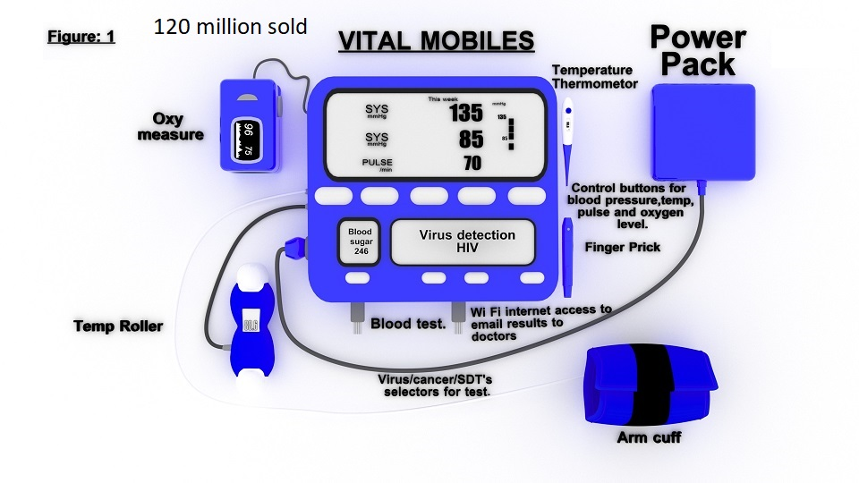
This device can also be used in hospitals as vital sign measurement in hospitalized patients are exposed to operational errors and they are also time-consuming. The Vital Mobile Device which is a smart all-in-one device is capable of testing for 50 different viruses along with human vital tests like Diabetes/sugar. This will improve patient monitoring, reduce measurement time, incorrect inputs in the Electronic health record (EHR) and inter-observer variability. Vital Mobile Device is equipped with both wired and wireless accessories that measure the important Vitals like oxygen level, blood pressure, pulse, temperature, STD’s, Pregnancies and cancers. The device not only has a touchscreen feature but also it is also equipped with buttons to make selections. The adapter of the device is available in three different connection types which means a normal home connection, a car lighter connection, and a USB connection with rechargeable batteries as well. The measurement of the console is 9 inches with a 8 inches screen and a length of 5 inches. There are six different accessories for testing purposes:
- The first accessory is a finger slip which is used to measure Oxygen level.
- The second is a blood pressure cuff which is used to measure blood pressure.
- The third is a finger prick which is connected to the console to measure diabetes, blood sugar, STD’s and different 50 different viruses/diseases.
- The fourth is a roller temp which is used to measure temperature/fever of a person. The roller can be used to scan the forehead.
- Fifth is a slip in taker which is used to measure STDs, blood glucose, Cancers, and pregnancy.
- Optional/An EKG accessories to measure the electrical current of the heart.
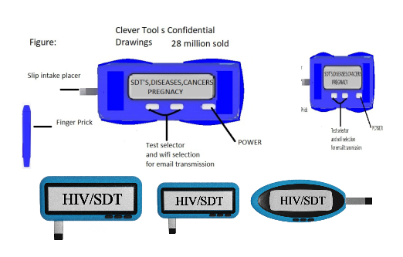
The height of the console of the smaller unit which is a mobile disease tester is 2 inches whereas the length of the overall device is 3 to 4 inches which means it is easy to carry. It is also available with three adapter connectors and rechargeable batteries. The viruses are saved in the NVRAM of the device to match the finger prick blood. All the results are saved on the console which also has a Wi-Fi internet access so it can be used to send email to the doctor. This smaller device is specially designed for Promiscuous people and tourists for tropical diseases.

Conclusion
The medical industry in the United States needs to improve the health of the general public, and the cost of providing health care should also need to reduce. Vital Mobile Device promises to advance both of these goals. However, to enable good health care it is important to test yourself on a regular basis for STD’s, Cancers, and other vitals. This medical device is specially designed to be accessible, safer, usable, and available to more people. This kind of advance devices aims to offer processes and principles that are needed to support the medical industry and to provide an easy and affordable health care solution.

