Rotating Motion Power
Generation by Harnessing High Altitude Wind

This system is made up of the 3 main parts as follows:
- Flying Frame:
As per drawings and video taped prototype, the frame looks like a kite to a large extent. In the front it has a closed triangle surface, followed by a rectangular frame on which a sliding closed surface is positioned. This sliding surface can be either square or rectangular in shape. When facing the wind, the sliding surface moves upward carrying the side of the rectangular frame where the sliding surface is located. This causes the sliding surface to slide to the opposite side of the rectangular frame ,so this cycle will keep going on so long as there is sufficient wind power causing the flying frame moves Alternatively. We can also add some additional surface areas such as the closed rectangular surface which is next to the rectangular frame as per diagram (not on prototype) so that the upward force for the flying frame is increased. The flying frame ends with a tail which helps to keep it facing the wind flow direction. The flying frame is connected from the front and above to a balloon which has enough power to lift and keep up the flying frame and all connected ropes when the flying frame starts flying from the ground and when the wind is not strong enough to lift up the flying frame. This frame must be manufactured from light weight and durable materials.

2 – Ropes which are connected to the flying frame towards the ground:
As per drawings and videotaped experiment, there are 4 ropes A, B, C&D (only in the videotaped experiment, the rope A is not included). Ropes A& B are fixed into the ground (in actual performance we may discover no need for rope B which I fixed here due to experimental circumstances). In case rope B was not necessary then it will be substituted by ropes C & D to connect the tail side of the flying frame into the ground. Ropes C & D have fundamental task which is to pass the alternative motion of the flying frame to the device for converting the alternative motion to a rotating motion that is on the ground. Some further testing may be needed to decide on the optimum position to fix the ropes C & D into the flying frame. I believe as per attached drawings that the best way to connect these ropes is by having 4 ribs meeting in one point at the bottom in the shape of upside-down pyramid. The length of ropes equals the altitude which is required to be the flying frame flying at (this altitude may be from several hundreds of meters to several kilometers). These ropes must be manufactured from a light weight and durable material.

3 - Device for converting the alternative motion to a rotating motion:
This device is fixed on the ground. It converts the alternative motion of the flying frame (which is transferred to it through the ropes C & D) to a rotating motion. Following are two designs for this device which are similar in the principle of operation and both are designed as a box which is fixed on the ground that has two arms and a rotating shaft that extends out of the box to be connected to the machine which is needed to be run by means of this generated rotating motion. The optimum design which is more suitable with the flying frame movement can be selected afterwards depending on the outcome of the actual experiments.

- First design :
This is made clear via the drawings which show the complete system (which are included in fig (1)). The rotating shaft lies inside the box along the longitudinal dimension of the box and one of its ends extends out of the box. The two arms are stationed vertically into the rotating shaft so that each arm has a round hole where the rotating shaft is centered in the middle. The other end of both arms, one of them is connected to the lower end of rope C and the other to the lower end of rope D. A mechanical device is fixed in between of the round hole of the arm and the rotating shaft which allows for a mechanical engagement between the arm and the rotating shaft only when the arm is pulled upward by the rope so the rotating shaft will gain a rotating motion , however, when the arm is let to fall down (when the rope moves downward),this mechanical device does not allow for a mechanical engagement between the arm and the rotating shaft so the shaft will not rotates in this case (similar to the mechanism which engages the chain with the back wheel of a bicycle). Therefore the rotating shaft keeps on rotating as a result of the successive and alternative pulling of the ropes C & D to the ends of arms. This generated rotating motion is uni-directional and will not be affected even by the complete stopping and re-starting of the flying frame due to the lack of wind power at any time.

- Second design :
This is made clear as per fig (2). The rotating shaft lies inside the box vertically to the box's longitudinal dimension while the two arms extend out of the box from opposite-two sides of the box along the longitudinal dimension of it (contrary to the first design). The two arms are not stationed into the main rotating shaft which extends out of the box but rather they are stationed into a secondary rotating shafts which are parallel to the main rotating shaft. As per the first design, the other end of both arms, one of them is connected to the end of rope C and the other to the end of rope D and each arm is stationed into one of the secondary shafts using the same mechanism as described in the first design so that each secondary shaft rotates only when the arm is pulled upward by the rope. The rotating motion of both secondary shafts is then introduced to the main rotating shaft by means of special gears as per fig (2) causing the main shaft to rotate as per the first design by the successive and alternative pulling of the ropes C & D to the ends of arms. The generated rotating motion which could be taken from the main rotating shaft is also uni-directional even if the flying frame will stop and re-start due to the lack of wind power as mentioned above.

Remarks:

- The rotating shaft can be fitted with a certain mass which will increase the moment of inertia of the rotating shaft and thus the rotating motion will be more stable and smooth.

- It is Possible to connect many modules of this system mechanically by connecting the rotating shaft of each module to the other then this created combinational rotating shaft (which acts as a crank of a car's engine while the multi- modules acts as its pistons) can be connected to a one huge power generator and that reduce the cost and make the output rotating motion more stable and smooth.

- It's possible to apply this technique for medium altitude wind too.

- The oscillating motion of the two sides of the flying frame upward and downward is not the only movement, the all flying frame also will move horizontally to left and right responding to the horizontal component of the force applied on the sliding surface, and that leads to more gain.

- In addition to the main concept, I have several ideas which are as solutions for potential problems which may face this technique such as, a solution for possible problem of a catenary slack, a solution for possible problem of a wide change in wind direction …etc, and ideas which can be implemented to increase the gain of this technique.

- The German company DSM Dyneema manufactures special fiber ropes which are 15 times stronger than steel (according to an article about AWE at the web site: http://www.greentechmedia.com/articles/read/will-the-netherlands-rule-high-altitude-wind/ ) and using such ropes (and it may be possible to manufacture the flying frame using this material too) reduce the weight widely and this is an important factor in this technique.

Drawings :

Fig. (1 – A).
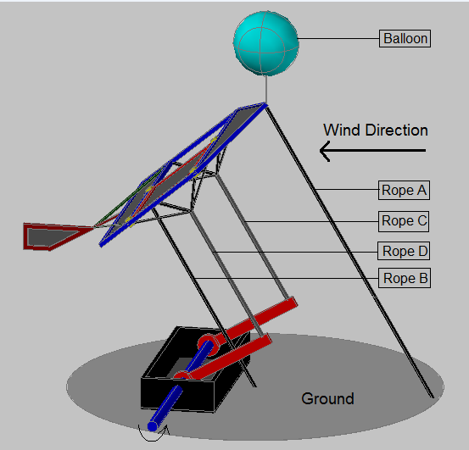

Fig.(1 – B).
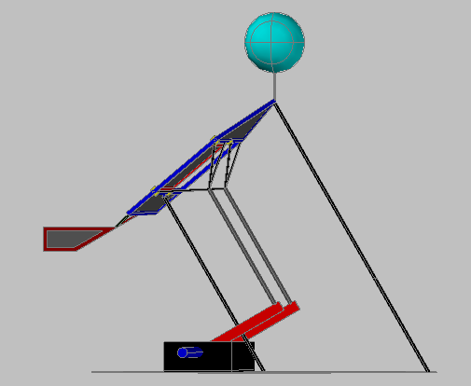

Fig. (1 – C).

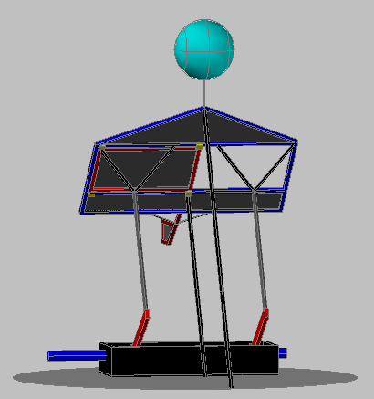

Fig.(1 – D).
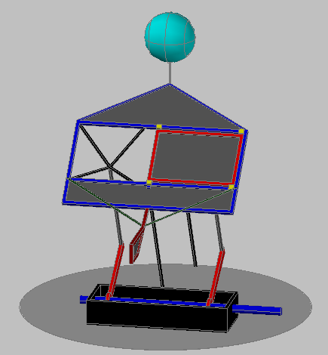

Fig.(1 – E).
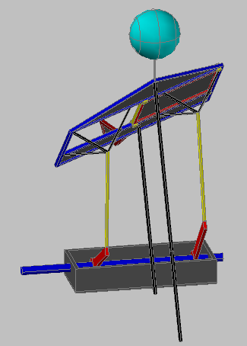

Fig.(1 – F).
